A Fitz Style Journal Entry
Set the Scene & State the Theme;
Say What You Mean, & Finish It Clean!
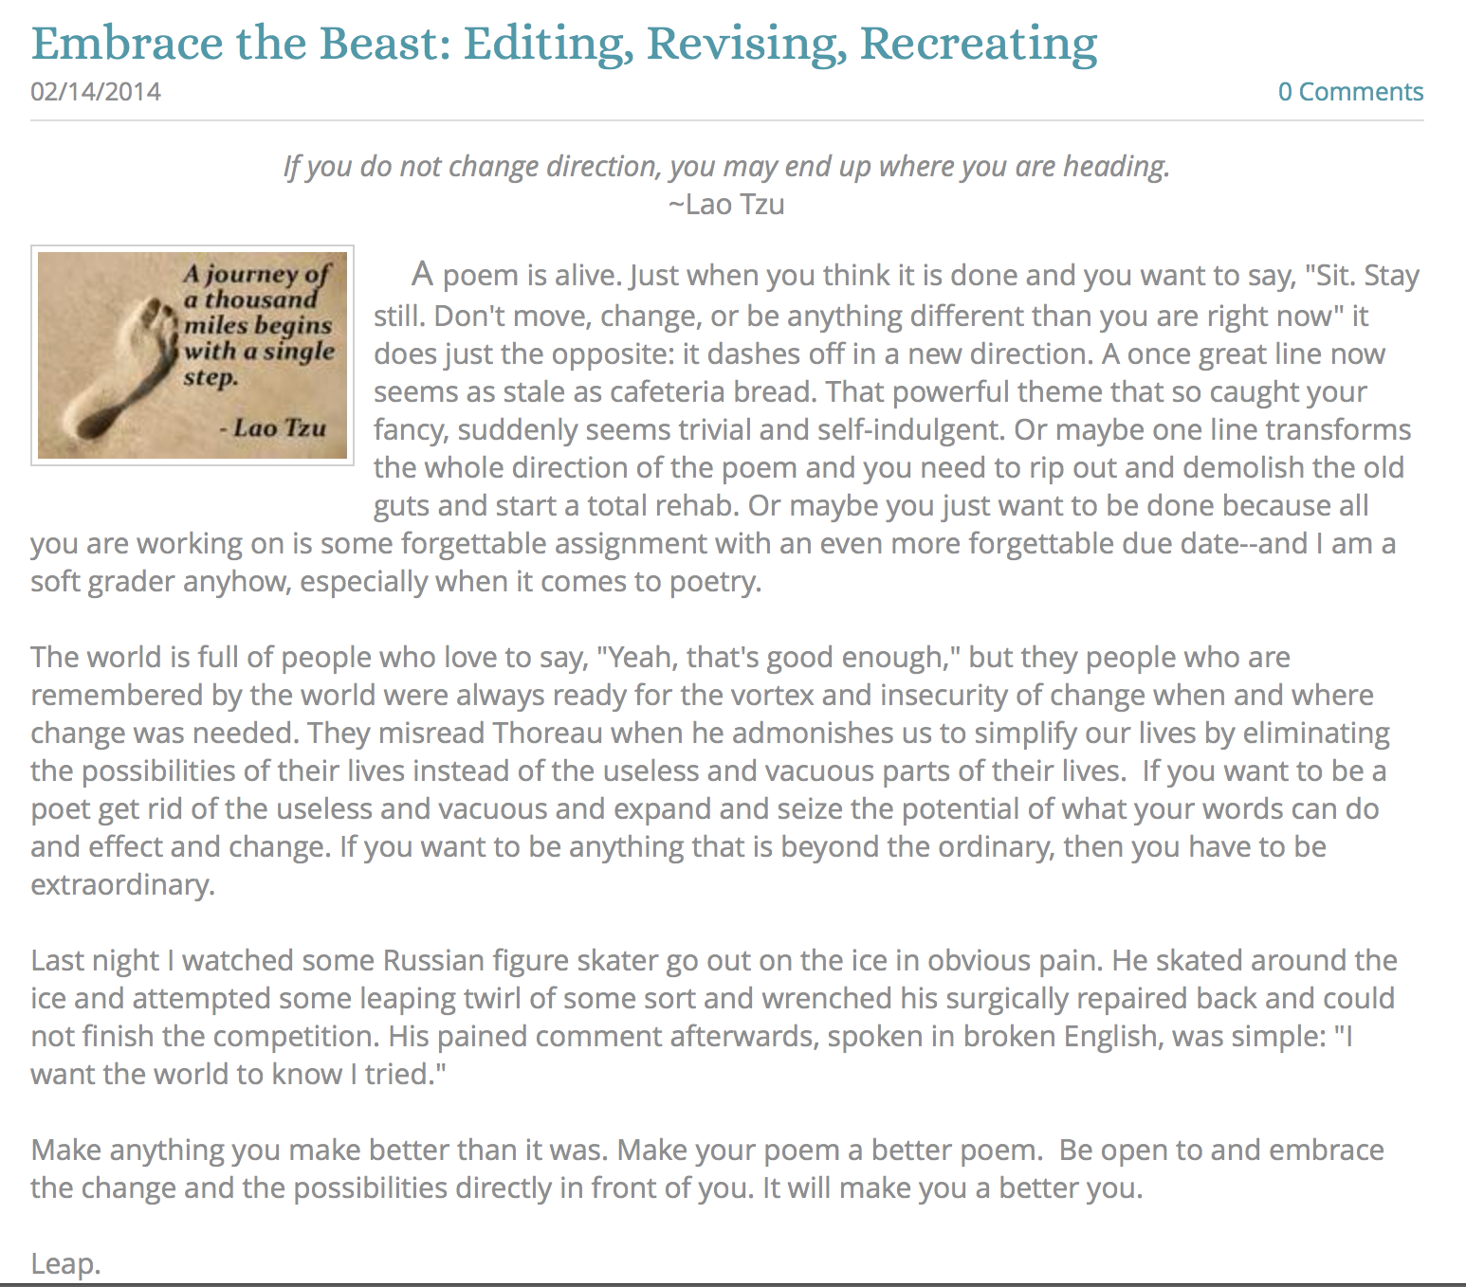
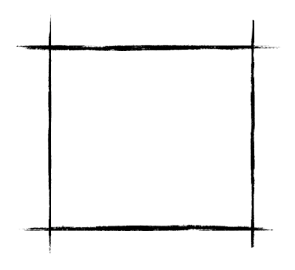

When writing a blog post, is important to remember that a reader is also a viewer. He or she will first “see” what is on the screen, and that first impression will either attract their attention and interest—or it may work to lose their attention and interest; hence, a bit of “your attention” to the details will go a long way towards building and maintaining an audience for your work. Plus, it gives your blog a more refined and professional look and feel—and right now, even as a young teenager, you are no less a writer than any author out there.

So act like a writer. Give a damn about how you create and share your work and people will give a damn about what you create! It is a pretty simple formula.

Below is a rubric for how to create a “Fitz Style” journal entry. I call it “Fitz Style” only because I realized that over time my journal posts began to take on a “form” that works for me. Try it and see if it works for you. You can certainly go above and beyond what this does and add video or a podcast to go along with it—and certainly more images if it is what your post needs. Ultimately, your blog is your portfolio that should reflect the best of who you are and what interests you at this point in your life presented in a way that is compelling, interesting, and worth sharing.
one of the hardest parts of writing is finding a way to make sense of what you want to say, explain, or convey to your readers--especially when facing an empty page with a half an hour to kill and an entry to write (or a timed essay or exam writing prompt). Here is a quick formula that might help you when you need to create a writing piece "on the fly." At the very least, it should guide you as your write in your blog, and at the really very least, it will reinforce that any essay needs to be at least three paragraphs long! I've always told my students (who are probably tired of hearing me recite the same things over and over again): "If you know the rules, you can break them." But you'd better be a pretty solid writer before you start creating your own rules. The bottom line is that nobody really cares about what you write; they care about how your writing affects and transforms them intellectually and emotionally as individuals.

If a reader does not sense early on that your writing piece is worth reading, they won't read it, unless they have to (like your teachers), or they are willing to (because they are your friend). Do them all a favor and follow these guidelines and everyone will be happy and rewarded. Really!

Formatting
How something “looks” is important. Never publish something without “looking” to see the finished product in your portfolio or blog.

Interesting Title
After the initial look, the title is the first thing a reader will see. The title should capture the general theme of your journal entry in an interesting and compelling way.

Interesting Title
After the initial look, the title is the first thing a reader will see. The title should capture the general theme of your journal entry in an interesting and compelling way.

Eye-catching Image
An image embedded in your post is the final touch of the formatting. A picture really does paint a thousand words and this final touch prepares your readers and entices them to read the important stuff—the actual writing piece you create.

Opening Paragraph

The “Hook!”
A hook is just what it says it is—a way to hook your reader’s attention and make him or her eagerly anticipate the next sentence, and really, that is the only true hallmark of a great writer!

Set the Scene
Use your first paragraph to lead up to your theme. If the lead in to your essay is dull and uninspired, you will lose your readers before they get to the theme. If you simply state your theme right off the bat, you will only attract the readers who are "already" interested in your topic. Your theme is the main point, idea, thought, or experience you want your writing piece to convey to your audience. (Often it is called a "Thesis Statement.)

State the Theme
I suggest making your theme be the last sentence of your opening paragraph because it makes sense to put it there, and so it will guide your reader in a clear and, hopefully, compelling way. In fact, constantly remind yourself to make your theme be clear, concise and memorable. Consciously or unconsciously, your readers constantly refer back to your theme as mnemonic guide for "why" you are writing your essay in the first place! Every writing piece is a journey of discovery, but do everything you possibly can to make the journey worthwhile from the start.

Body Paragraphs

Say What You Mean
Write about your theme. Use as many paragraphs as you "need." A paragraph should be as short as it can be and as long as it has to be. Make the first sentence(s) "be" what the whole paragraph is going to be about.

Try and make those sentences be clear, concise and memorable (just like your theme) and make sure everything relates closely to the theme you so clearly expressed in your first paragraph. If your paragraph does not relate to your theme, it would be like opening up the directions for a fire extinguisher and finding directions for baking chocolate chip cookies instead!

And finally, do your best to balance the size of your body paragraphs. If they are out of proportion to each other, then an astute reader will make the assumption that some of your points are way better than your other points, and so the seed of cynicism will be sown before your reader even begins the journey

Conclusion

Finish It Clean
Conclusions should be as simple and refreshing as possible. In conversations only boring or self important people drag out the end of a conversation.

When you are finished saying what you wanted to say, exit confidently and cleanly. DON"T add any new information into the last paragraph; DON'T retell what you've already told, and DON'T preen before the mirror of your brilliance. Just "get out of Dodge" in an interesting and thoughtful (and quick) way.

Use three sentences or less. It shows your audience that you appreciate their intelligence and literacy by not repeating what you have already presented!

Try Creating Your Own Fitz-Style Journal Entry

Title:

Place your title here

Quote:

Place your quote here

Image

Place your image here

Opening Paragraph

Hook:

Place your text here

Set the Scene:

Place your text here

State the Theme:

Place your text here

Body Paragraphs

Say What You Mean:

Place your paragraphs here

Conclusion

Finish It Clean:

Place your paragraphs here

