A Fitz Style Journal Entry
Set the Scene & State the Theme;
Say What You Mean, & Finish It Clean!

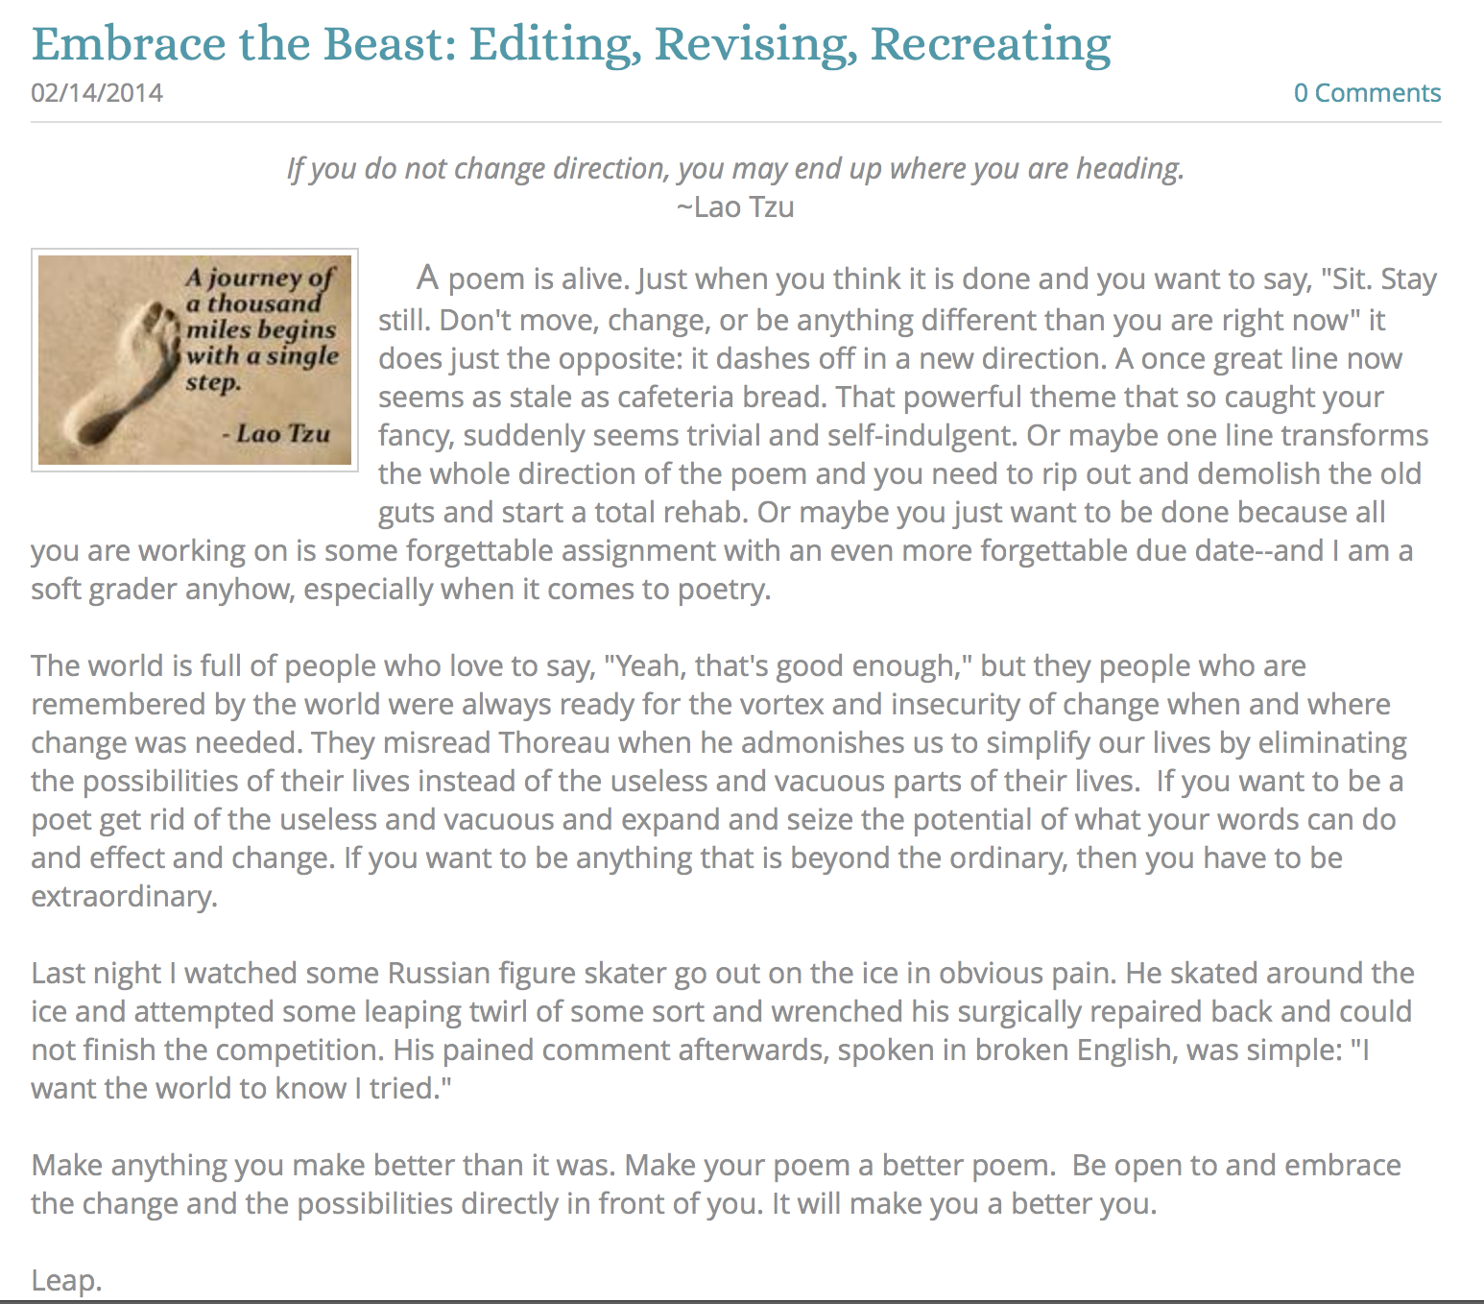

Use this ten-step rubric to create and post engaging and compelling blog posts!

When writing a blog post, is important to remember that a reader is also a viewer. He or she will first “see” what is on the screen, and that first impression will either attract their attention and interest—or it may work to lose their attention and interest; hence, a bit of “your attention” to the details will go a long way towards building and maintaining an audience for your work. Plus, it gives your blog a more refined and professional look and feel—and right now, even as a young teenager, you are no less a writer than any author out there.

So act like a writer. Give a damn about how you create and share your work and people will give a damn about what you create! It is a pretty simple formula.

Below is a rubric for how to create a “Fitz Style” journal entry. I call it “Fitz Style” only because I realized that over time my journal posts began to take on a “form” that works for me. Try it and see if it works for you. You can certainly go above and beyond what this does and add video or a podcast to go along with it—and certainly more images if it is what your post needs. Ultimately, your blog is your portfolio that should reflect the best of who you are and what interests you at this point in your life presented in a way that is compelling, interesting, and worth sharing.

One of the hardest parts of writing is finding a way to make sense of what you want to say, explain, or convey to your readers--especially when facing an empty page with a half an hour to kill and an entry to write (or a timed essay or exam writing prompt). Here is a quick formula that might help you when you need to create a writing piece "on the fly." At the very least, it should guide you as your write in your blog, and at the really very least, it will reinforce that any essay needs to be at least three paragraphs long! I've always told my students (who are probably tired of hearing me recite the same things over and over again): "If you know the rules, you can break them." But you'd better be a pretty solid writer before you start creating your own rules. The bottom line is that nobody really cares about what you write; they care about how your writing affects and transforms them intellectually and emotionally as individuals.

If a reader does not sense early on that your writing piece is worth reading, they won't read it, unless they have to (like your teachers), or they are willing to (because they are your friend). Do them all a favor and follow these guidelines and everyone will be happy and rewarded. Really!

Formatting

How something “looks” is important. The initial formatting of a blog post is incredibly important. Including an interesting title, a relevant and meaningful quote, and an image that reinforces your title and quote works to help you establish the theme, tone, and direction of your blog post. It prepares your readers for the writing that is to come—and, hopefully, fires them up as well!

1. Interesting Title
After the initial look, the title is the first thing a reader will see. The title should capture the general theme of your journal entry in an interesting and compelling way.

Put your title here

______________________________

2. Relevant Quote
  - A short and pithy quote works in tandem with your title to capture the essential theme of your entry.
  - Quotes are easy to find online—or make one up, or steal one from your writing piece.

Put your quote here

_____________________________

3. Eye-catching Image
  - An image embedded in your post is the final touch of the formatting.
  - A picture really does paint a thousand words and this final touch prepares your readers and entices them to read the important stuff—the actual writing piece you create.
  - If you do not have an image, search online for an appropriate image you can use freely.
  - Do not “link” to an image; instead, save the image to your computer or camera roll on your tablets.

Put your Image here.

______________________________

The Opening Paragraph

4. The “Hook!”
  - A hook is just what it says it is—a way to hook your reader’s attention and make him or her eagerly anticipate the next sentence, and really, that is the only true hallmark of a great writer!

[Put your hook here]

______________________________

5. Set the Scene
  - Use your first paragraph to lead up to your theme.
  - Your theme is the main point, idea, thought, or experience you want your writing piece to convey to your audience. (Often it is called a "Thesis Statement.)
  - If the lead in to your essay is dull and uninspired, you will lose your readers before they get to the theme.
  - If you simply state your theme right off the bat, you will only attract the readers who are "already" interested in your topic.

[Put your setting of the scene text here]

______________________________

6. State the Theme
  - State your theme in the last sentence of your opening paragraph.
  - It makes sense to put it there, and it will guide your reader in a clear and compelling way.
  - Consciously or unconsciously, your readers constantly refer back to your theme as mnemonic guide for "why" you are writing your essay in the first place!
  - Every writing piece is a journey of discovery, but do everything you possibly can to make the journey worthwhile from the start.

[Put your theme sentence(s) here]

______________________________

Body Paragraphs

7. Say What You Mean
  - Write about your theme. Use as many paragraphs as you "need." A paragraph should be as short as it can be and as long as it has to be. Make the first sentence(s) "be" what the whole paragraph is going to be about.
  - Create sentences that are clear, concise and memorable (just like your theme) and make sure everything relates closely to this theme you so clearly expressed in your first paragraph. If your paragraph does not relate to your theme, it would be like opening up the directions for a fire extinguisher and finding directions for baking chocolate chip cookies instead!
  - And finally, do your best to balance the size of your body paragraphs. If they are out of proportion to each other, then an astute reader will make the assumption that some of your points are way better than your other points, and so the seed of cynicism will be sown before your reader even begins the journey.

[Put body paragraph #1 here]

[Put body paragraph #2 here]

[Put Additional body paragraphs here]

______________________________

Conclusion

8. Finish It Clean
  - Conclusions should be as simple and refreshing as possible. In conversations only boring or self important people drag out the end of a conversation.
  - When you are finished saying what you wanted to say, exit confidently and cleanly. DON"T add any new information into the last paragraph; DON'T retell what you've already told, and DON'T preen before the mirror of your brilliance. Just "get out of Dodge" in an interesting and thoughtful (and quick) way.
  - Use three sentences or less. It shows your audience that you appreciate their intelligence and literacy by not repeating what you have already presented

[Put your conclusion here]

______________________________

9. Checklist:

  - Interesting title?
  - Relevant and menaingful quote?
  - Eye-catching image?
  - Good hook?
  - Set the scene?
  - State the theme
  - Say what you mean?
  - Finish it clean?
______________________________

10. Post to your blog:

    - Do whatever needs to be done to add this entry to your blog and/or portfolio.
    - Learn to use all of the tools and features of your blogging platform.
    - Embrace the mantra: “Figure it out!”
    - Never publish something without “looking” to see the published product in your portfolio or blog.

Thanks for trying it out, if you have any questions or comments, please let me know.

