How to Tell a Good Story

Creating a Descriptive Paragraph

Introduction

We are born to tell and listen to stories of all kinds, but the most popular and pervasive of these is the narrative story—a story which retells an experience in the first person. Every time someone asks you: “how was school? how was your trip? did you catch anything? what do you like about him? “was it a good game”? … and you answer with more than a grunted single-word response, you are telling a narrative story and YOU are the narrator. The only difference between a narrative story and a fictional story is how much you can play with the truth. The art of telling the story is the same.
Of course, some people tell better stories than other people, but why? The answer is probably because they tell more stories or they read more stories; they are not satisfied with the single grunt because they love and want to recreate the moment as vividly and compellingly as possible, and by the process of elimination and addition they have figured out how to tell a good story. Good storytellers know what goes into a good story, and, just as important, they know what to leave out. They know that a good story, well told, brings great satisfaction to them as the tellers and writers and to their audience as listeners and readers.
Truth be told, if you can’t tell a good story, it will be hard to get people to listen to you when you really want and need them to listen to you, like when you want to get into a certain school, or you want a certain job, or you are meeting new friends, or you are asking someone on a date, or you desperately need to get through that border crossing…really, anytime you are in a position where someone or somebodies want to hear your story, you need to be able to produce—and to produce, you need to practice.
Kind of like I am doing now.
Thankfully, you probably are already a good storyteller, at least in your head. The harder job is to get your mouth to say it like you think it or your hand to write it like you think it—it being the story. Sometimes this means you have to ignore what your teachers may have taught you about writing, for a good story needs to sing and flow with the unique rhythms of your natural way of speaking, which is rarely what a teacher is looking for in your essay. Imagine if your speaking was graded as harshly as your writing pieces? You would barely get out three sentences without being stopped dead in your tracks! Your mouth would be covered in so many red x's that you probably would never speak again--and that would be the end of good stories. At least from you. (Even now, my grammar checker is underlining way too many phrases and words--even whole sentences--with green scribbly lines asking me to reconsider how I am writing. I just ignore them. For now.)

The irony for you as a writer is that to recreate your inner voice into a story your readers enjoy reading, you have to write deliberately and carefully to be sure that it sounds and "feels" like you, and that (at least for me) takes a good deal of editing and revising and reading aloud--something most of us know how to do. We just don't do it enough. But if you do, and if you like what you have created: man oh man, what a great feeling!

Hopefully, I have written well enough that you are still with me, and if you are still with me, and if you want to be a better writer and teller of stories, you will "listen" just a bit longer. As Maria sings in "The Sound of Music" when teaching her gaggle of children: "Let's start at the beginning/ It's a very good place to start/ When we sing we begin with do, rei, me..."

Rule #1: Get your reader's attention!
- Your opening line is like the opening whistle in a soccer game, the first pitch in a baseball game, or the kickoff in a football game. It creates excitement and anticipation. No one knows what exactly is coming, but it certainly keeps us in our seats to see what is coming.
- Your opening line (or sometimes even just a word!) should be an expression of your passion for the story you are about to tell. As Robert Frost once said: "If there are no tears for the writer, there are no tears for the reader." So open with a line that gets you as excited as your reader.
    - I enjoy fishing. [NO NO NO: Nobody cares about you!
    - It was a day that every fisherman lives for. [YES YES YES: Every fisherman that has ever fished (or wishes to fish) lives for that day!]
    - Sally is a good friend of mine. [Nooooo….who cares, unless Sally is some kind of something who we all know]
    - A good friend stands by you come hell or high water. [Yessssss! Everybody (especially your readers) wants a friend like that.]

Rule #2: Paint visually rich scenes.
- Your readers need to see and think and feel the way you see and think and feel. They are not in your head, so you need to put them in your head using images and actions, which are created using nouns and verbs, not vague thoughts. Brain studies have proven that when a brain is presented by words representing images and actions, the part of the brain that commands motion is prompted into action. This is a great time to use similes and metaphors to help make your words feel alive and real ad make your reader feel the motions of your narrative.
    - The weather was lousy. [NO NO NO: What do you even mean by lousy weather?]
    - The clouds cracked open and dropped unending sheets of pelting rain that scattered the screaming children like startled blackbirds from a muddy field. [YES YES YES: Your reader’s brain is now saying, "Run, run for cover!" and they are now a part of your story, not just a passive onlooker.]
    - The game was really long. [Noooooo: what do you mean by long? Everybody has a different idea of what long means.]
    - The game dragged on like a dull movie until even the referee was snoring. [Yessss....Now we know what you mean by loooong.]

Rule #3: Weave your thoughts into the story
- Tie your thoughts directly to the images and actions of your story. No one really likes to hear or read a story that is just a bunch of one person's thoughts. Once your readers are engaged in your story, they will relish your thoughts about what is happening, and, if done well, these thoughts will spark their own thoughts, and not only will they be reliving your story, they will be creating a story of their own; they will wonder what they would think and feel and do in that same situation. The story then becomes their wondrous story, too—not just your story.
    - The weather was lousy. I wish I wasn't there.
        - NO NO NO: Stating the obvious is not stating much at all. And, oh yeah, nobody cares about you--unless you make them care through the miracle work of words strung like emeralds in the sky.
    - The clouds cracked open and dropped unending sheets of pelting rain scattering the screaming children like startled blackbirds from a muddy field. I could almost hear them thinking "Why did I ever come to this godforsaken place!" In the chaos of the mad cloudburst we must all have been experiencing the same nightmare of being in the wrong place at the wrong time, but at least we were all in it together. YES YES
          - YES: This is not just sorry old you in a rainstorm; it is everybody who has ever been caught in the wrong place at the wrong time—and a universal and vexing conundrum.

Rule #4: The End is a new beginning
- Your story may seem to end with the last line, but for your readers, the end is a new beginning full of the thinking and pondering and satisfaction that is evoked from a story well-told. No reader wants to hear or read, "That's it. It's over. Move on." We don’t need to be reminded with some pithy summary that your story is over because we know it’s over. If we are reading your story, we can see it ending; if we are listening to your story, we will hear your story drawing to its close. This is not the time to point in the casket and say, “He’s dead,” as if it is a revelation we need to hear. It is a time, however, to more carefully and precisely craft your words into a final gift to your audience—like a parent, friend, or lover pressing a handful of gems into your palm before you leave on a journey and saying, “Here, take these; use them as you need them!” Your final words should read more like poetry than prose—a final reward of the best your head can create because the story is no longer yours: it is ours.
  - Not… “Sooo, that’s Johnny Fitz’s story about catching a big fish.”
  - But like Norman Maclean in the closing of A River Runs through It: “I am haunted by waters.”
  - Not… “This was an experience no one should have to go through.”
  - But like Joseph Conrad in the last phrases of The Heart of Darkness: “The Horror, the horror.”
  - Not… “It is important that all of us live and think differently.”
  - But like Henry David Thoreau in the last words of Walden: “The sun is but a morning star.”
Every story is ultimately given away. It ends when you abandon it to your audience, and it then becomes a new experience—a new beginning—for your audience, and it is these final words they will mince and chew on through eternity, and so they should be crafted with care; however, remember that you have already given your audience the meat and bones of your story, so you do not need to feed them again with any kind of bland and boring summary.
When I finish reading or listening to a really good story, whether it is a real or fictional story, I get an urge to sit down and think for a really, really long time. The better the story, the longer I think.

~fitz

Paragraph Prompt:
The Power of Place

Everyone has a place that at some point in their lives—or in an ongoing way in their lives—was or is incredibly special for deep and meaningful reasons. To recreate the power of that place a writer needs to use vivid imagery that uses as many of our “senses” as possible. This is commonly called “Figurative Language.”

For this prompt, think of a time and place and experience that is uniquely your own. It does not have to be an amazing experience in an amazing place. In fact, the best places are usually pretty common and accessible. If it is too amazing, you may lose your readers because your place and experience becomes something your readers can’t relate to in a common way. Your readers need to share in the joy and meaning of your place, what you did, and how it affected you.

This rubric breaks a paragraph into three sections.

All of this is essentially the same as the narrative paragraph rubric because descriptive writing is just another way of approaching narrative writing. In this assignment the focus is about the power of a place as well as the experience you had in that place.
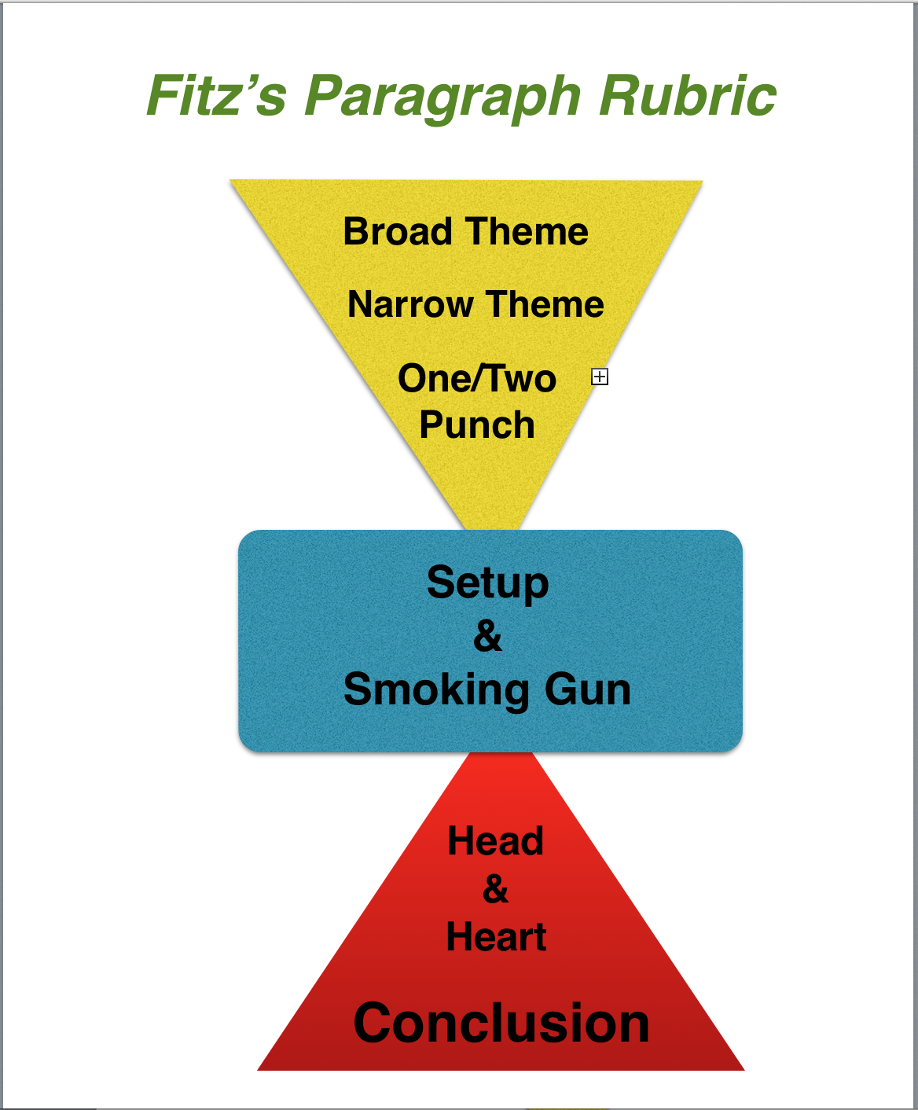

  - The first part of the paragraph introduces and narrow downs a theme from a broad theme (interesting and catchy enough to anyone) to a more narrow and focused theme that a writer can explore and explain in a single paragraph of 350 words or less, (but seldom less than 250 words).

  - The central part of the paragraph (the setup and smoking gun) focuses on introducing and describing the experience that captures the essence and importance of your theme in a series of images and actions that tell the who, what, when, where, and why of the experience. (This is similar to text support or facts in expository or analytical writing). It proves the author has the authority and enough experience to write about this theme from the point of view of someone who has lived through the experience—and now has a story to tell that is meaningful, memorable—and above all, written with real and natural narrative voice.

  - The last third of the paragraph (the head & heart and the conclusion or transition) explicates (which means to explain in detail) how the theme works within the place and experience the author just described. In the diagram you can see how the triangle starts small (narrow) and expands back towards a solid base. In practice, the writer should focus first on the parts of the experience that show the theme in action. Towards the end of the paragraph, the writer can (he or she does not have to) write about the importance of the theme in a more universal way.

  - The closing line or transition will either be a brief and pithy conclusion or a series of sentence that transitions to a new paragraph that is logically linked together with the paragraph just completed.

NOTES
Read each section carefully to be sure you are following the flow of the rubric. A narrative writing piece needs to have the natural flow of human speech to be effective. If it is too choppy, it will be an ineffective piece because it won't feel or sound real.

Remember that no writing piece is ever “done.” It is abandoned, and every minute before that time is a good time to “change” your paragraph for the better. Before you abandon this piece, let it sit for a couple of days, then go back to it with fresh eyes and a fresh mind and do what you need to do to make it more perfect—at least in your mind.

This rubric, if used wisely, is essentially a brief essay—and a damn good one if you give it the time and focus that well-crafted writing needs.

STEPS OF THE RUBRIC: Read each section carefully and try to follow all of the steps of the rubric. Read each section out loud or use text to speech and proofread carefully. A narrative should “sound” just like you would speak. Except better.

1. THE MAJOR THEME:
Writing out your theme as a single word or short phrase is a good way to help keep focused as you write the paragraph. Put your one word or short phrase theme centered on the page. It should constantly remind you that THIS is the theme you have to stay focused on throughout your paragraph!
It can also work as a title!

The Power of a Place

[Put your theme here]

2. GUIDING QUOTE:
If you are only writing a single paragraph, I think it is a great idea to put a quote above the paragraph that captures the mood, tone, and theme of your paragraph.

For example: if I wish to write about the power of family, I could use a quote like this, put in italics, with the author’s name below the quote.

I never saw the morning 'til I stayed up all night.
I never saw the sunshine 'til you turned out the light.
I never saw my hometown until I stayed away too long
~Tom Waits

[Put your text quote here]

3. BROAD THEME:
Write a short declarative statement that touches on a broad theme that all of us can relate to in some way or other. This acts as a "hook" that will attract your reader's attention. Despite what you might wish, no one really cares about you when they read; a reader cares primarily about himself or herself. This broad theme is a theme that almost any person can relate to on some level, and hopefully it is intriguing enough to make your reader want to read on. Do not mention you or your place in this sentence!
For example: if you want to write about the importance of a place where you had a profound experience, here is an example of a broad theme:
- The power of a place is measured by how much it teaches us about ourselves.

[Put your text here]

4. NARROW THEME:
Narrow down your theme by writing a phrase or sentence using the theme word that captures how your chosen theme is used in a specific way in the experience you are going to write about. Make sure it is "clear, concise and memorable" because this is what you want your readers to remember "as" they read your paragraph. This is the sentence that "steers" your reader in the direction you want your paragraph to go, and in that sense, it is what your paragraph is going to be about. YOU should be in this sentence; otherwise a reader may be misled into thinking you are merely writing about the importance of the theme, not about an experience you have had.
For example:
- Days and days of heavy rain was all it took for me to appreciate the power of our summer home in Windsor, New Hampshire.

[Put your text here]

5. ONE/TWO PUNCH:
Follow your topic sentence with one or two more sentences that add detail or explanation to your topic sentence. These sentences can (and maybe should) be longer sentences. This helps to “narrow down” the focus of your paragraph so that you only have to write what can be fully explained in one paragraph.
For example:
- I’ve always loved the pond and the woods and getting away from the business and distractions at home, but I never knew how much I appreciated this place until I thought I didn’t.

[Put your text here]

6. SET UP:
The setup is the lead-in to your smoking gun. It prepares your reader for the description of your experience in your place in the smoking gun by giving context to the experience. The setup wants to include most—if not all of these: (It does not have to be in this order.)
  - Who is there?
  - What is happening?
  - When is it happening?
  - Where is it happening?
  - Why is it happening?

For example:
  - Finally, the tall green pines standing sentinel around this cold and black New Hampshire pond are framed in a sky of blue. After a month of steady rains, foggy nights, and misty days, I am reborn into a newly created world—a world that finally answered my prayers.

[Put your text here]

7. SMOKING GUN:
When writing about a personal experience in a place, chose a specific personal experience (or even a smaller part of an experience) that explicates, illustrates, and amplifies the theme of your paragraph. This personal experience is proof that you have been there and done that, which is why we call it the smoking gun! It is evidence that you are the one who had the experience that only YOU can write about with full authority. When you write the smoking gun, be sure to include as much detail as needed—the who? what? when? where? and why?—to fully capture the theme of your paragraph.
For example:
- No more trying to find that elusive spot under the camper awning that doesn’t seem to leak; no more running across the wet field dragging Tommy bouncing and laughing like a half-inflated beach toy towards a smokey campfire: and (almost regrettably) no more endless scrabble, card games, monopoly, and shallow books.

[Put your text here]

8. HEAD & HEART:
Show your reader your thoughts! Write as many more sentences as you "need" (but at least three more) to illustrate and elaborate upon whatever you introduced in your theme-setting sentences. This is where you reflect upon your experience and describe the ways that your experience reflects your broad and barrow theme. [My head and heart in this paragraph is long because I had a lot I wanted to say]

For example:
- This fresh blue morning barks out the possibilities of the day: Here is my rope-swing. Here are my trails. There lie my waters….The window is small and the day is large. I shouldn’t be here teasing words from an empty page when I should be embracing the possibilities of today. As Thoreau said: My life is the poem I should have writ/ But, I could not both live and utter it. The ignorant and lazy part of us might want to rally around Thoreau’s sentiment and say, “Amen to that,” but we would miss the irony and wistfulness of our collective predicament: like kids balancing on a plank set on a log, we scramble back and forth to find that sweet spot on the plank, that place of perfect balance between the forces of yin and yang—but, if we find that spot, we allow ourselves only a few moments of self-indulgent awe before searching for a more elusive and demanding challenge. To live fully, we must be bored quickly by the easy and mundane. We have to set a larger plank across a bigger log. There is no legal limit to how many balls a juggler can have in the air. We are only captive to gravity and the sun ticking its way towards the horizon.

[Put your text here]

9. Concluding Thoughts! (The get out—or go on
This sentence either wants to close out your thoughts or "transition" to a potential new paragraph. Here I am “getting out” as I am writing a single meaty paragraph.
Notice how I use the repeating phrase “I need…” to create a series of sentences. This is called Parallel Structure, and it is a time-honored technique that has been for centuries of writers and storytellers—because it works. Try it. You will not be copying me; you will be imitating what great writers have practiced time and time again.

Finally, create a really cool and interesting sentence to finish your paragraph.

For example:
  - I need this blue sky to let me see the horizon and the infinite juxtapositions between the earth and sky. I need to be reminded that my page will always be empty if I don’t embrace the day that comes before it. I need to rush headlong into the blinding light. I need to fall and get up time and time again with a contagious and courageous rhythm, and I need to remember to spend my day and not simply save it, as if I could redeem it tomorrow. My life and these words are my final redemption, rushed and woven imperfectly into the rags I wear.

[Put your text here]

10. Copy and Paste Completed Paragraph Here:

I can’t emphasize enough how important it is for a paragraph to look as good as it sounds. For my paragraph, I am going to use a title, a quote, AND an image. The title, quote, and image work together to prepare and guide your reader in the direction your paragraph is going to go. Don’t forget to put your name somewhere. It is, after all, your creation!
Sometimes a paragraph gets too long. If that is the case, you can create a mini-essay out of the paragraph by breaking it into three paragraphs. The broad theme, narrow theme and one/two punch can be your opening paragraph. The set up and smoking gun can be the second and third paragraphs, the head and heart can be your fourth paragraph, and the final line can be your really cool and pithy conclusion—and, Voila! You have a five paragraph essay. Pretty cool, eh?
My paragraph is almost exactly 500 words. Yours can, of course, be considerably shorter, but try to write at least 300 words.
Here’s mine. Now it’s your turn.

The Power of Place

I never saw the morning 'til I stayed up all night.
I never saw the sunshine 'til you turned out the light.
I never saw my hometown until I stayed away too long
~Tom Waits

The power of a place is measured by how much it teaches us about ourselves. Days and days of heavy rain was all it took for me to appreciate the power of our summer home in Windsor, New Hampshire. I’ve always loved the pond and the woods and getting away from the business and distractions at home, but I never knew how much I appreciated this place on Windsor Mountain until I thought I didn’t. Finally, the tall green pines standing sentinel around this cold and black New Hampshire pond are framed in a sky of blue. After a month of steady rains, foggy nights, and misty days, I am reborn into a newly created world—a world that finally answered my prayers: no more trying to find that elusive spot under the camper awning that doesn’t seem to leak; no more running across the wet field dragging Tommy bouncing and laughing like a half-inflated beach toy towards a smokey campfire: and (almost regrettably) no more endless scrabble, card games, monopoly, and shallow books. This fresh blue morning barks out the possibilities of the day: Here is my rope-swing. Here are my trails. There lie my waters….The window is small and the day is large. I shouldn’t be here teasing words from an empty page when I should be embracing the possibilities of today. As Thoreau said: My life is the poem I should have writ/ But, I could not both live and utter it. The ignorant and lazy part of us might want to rally around Thoreau’s sentiment and say, “Amen to that,” but we would miss the irony and wistfulness of our collective predicament: like kids balancing on a plank set on a log, we scramble back and forth to find that sweet spot on the plank, that place of perfect balance between the forces of yin and yang—but, if we find that spot, we allow ourselves only a few moments of self-indulgent awe before searching for a more elusive and demanding challenge. To live fully, we must be bored quickly by the easy and mundane. We have to set a larger plank across a bigger log. There is no legal limit to how many balls a juggler can have in the air. We are only captive to gravity and the sun ticking its way towards the horizon. I need this blue sky to let me see the horizon and the infinite juxtapositions between the earth and sky. I need to be reminded that my page will always be empty if I don’t embrace the day that comes before it. I need to rush headlong into the blinding light. I need to fall and get up time and time again with a contagious and courageous rhythm, and I need to remember to spend my day and not simply save it, as if I could redeem it tomorrow. My life and these words are my final redemption, rushed and woven imperfectly into the rags I wear.
~John Fitzsimmons

THE POTSAID RULE OF THREE:
Proofread, Edit, Revise, & Submit
- Literature is abandoned, not finished! Go back and re-read what you have written.
- Find three areas or sentences that you can make better. If you can't or won't do this, then you are light years away from being a writer.
- Often you can find a better broad or narrow theme sentence somewhere else in the paragraph. You can almost always find a more clear and effective way to write a sentence than you wrote on your first try.
- If the rule of three was too easy (meaning you easily found mistakes) do it again...and again if you have to.

*When you are convinced you have done all you can, submit your final review as required by your teacher or editor.

